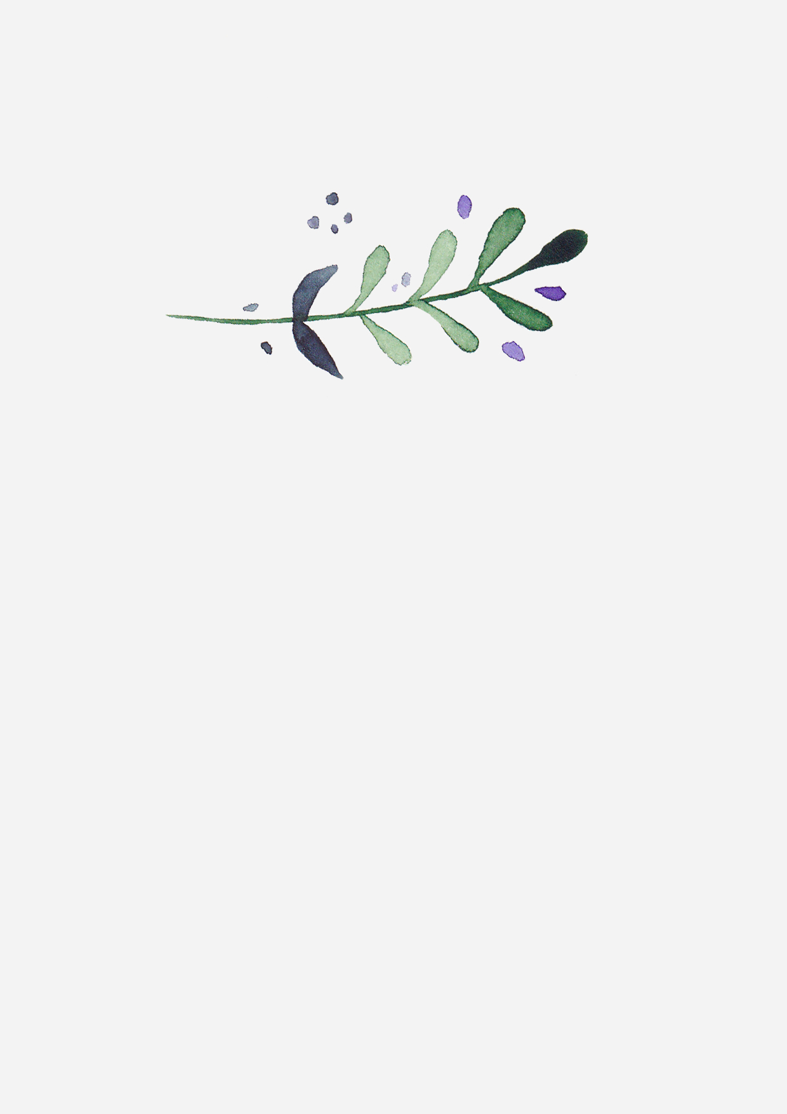

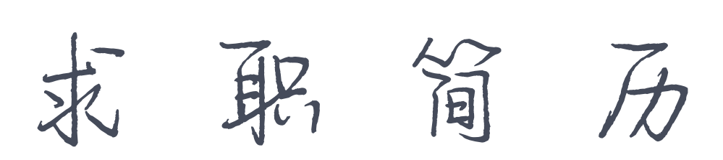

PERSONAL RESUME

|  |  |
| --- | --- |
| 1 | 姓名：李冉冉 |
| 4 | 电话：18688888888 |
| 3 | 邮箱：caigou@iiquan.com |
| 2 | 求职意向：美术主编 |