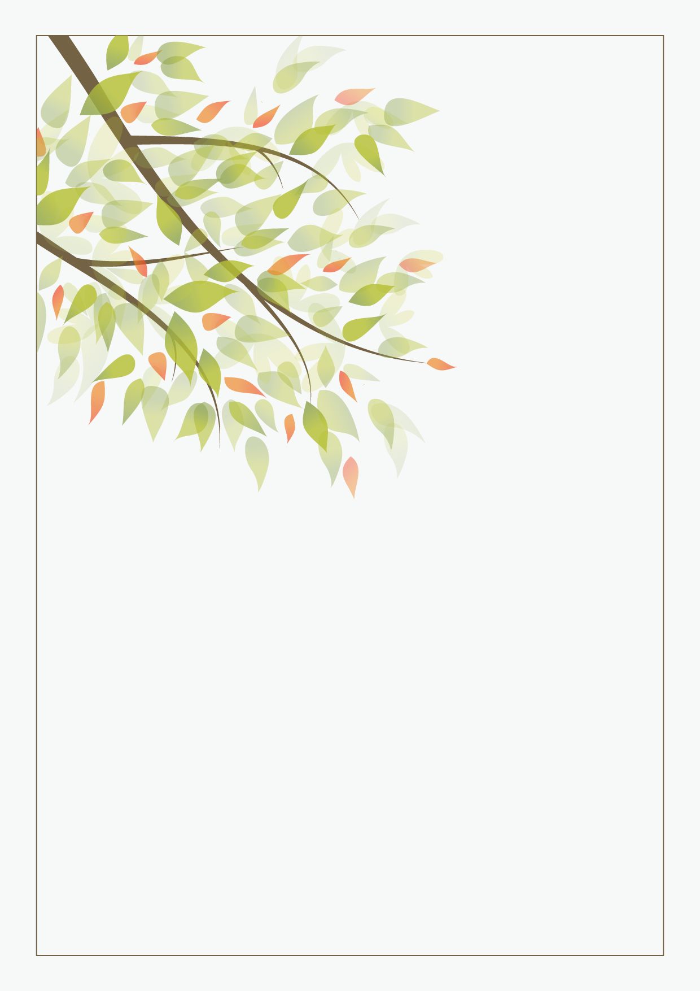

PERSONAL RESUME

|  |  |
| --- | --- |
|  | 姓名：杨珍珍 |
|  | 电话：188-8888-8888 |
|  | 邮箱：caigou@iiquan.com |
|  | 求职意向：美术主编类相关职位 |